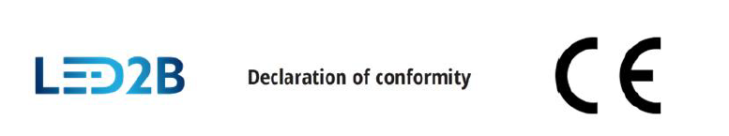

No 3/2024
Manufacturer: | Kobi Light Sp. z o.o.  35-105 Rzeszów, ul. Boya-Żeleńskiego 2
We declare with full responsibility, that our product:
Product: | LED Solar LED garland for garden

Name: | SOLAR 10 LED STARLIGHT LED2B*(1), SOLAR 20 LED STARLIGHT LED2B*(2), SOLAR 30 LED STARLIGHT LED2B*(3), SOLAR 30 LED AURA LED2B*(4), SOLAR 300 LED SPARK LED2B*(5), SOLAR 50 LED LUME LED2B*(6),
* = WW, NW, CW
(batch number XXYY)
(XX – year, YY – month)
Specification: | IP44; CLASS III; 0,06W(1,2); 0,08W(3,4); 0,15W(5); 0,12W(6)  Battery: AA; DC 1,2V; 300mAh(1,2), 400mAh(3,4), 800mAh(5), 600mAh(6)  Solar Panel: 2V, 120mA, 0,24Wp;
Is in compliance with following documents of reference:
Directives: | 2014/30/EU  2011/65/UE, (EU) 2015/863

Harmonized standards: | EN IEC 55015:2019+A11:2020  EN IEC 61547:2023  EN 63000:2019-01
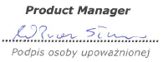
This declaration is issued under the sole responsibility of the manufacturer
Rzeszów 18.01.2024
Place, date
Product Manager

………………………………………
Signature of an authorized person

